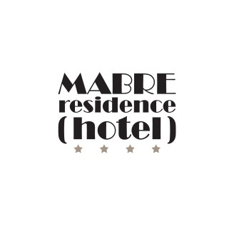 3rd Congress of Baltic Microbiologists (CBM2016)

Hotel reservation form
Guest Name

Guest Address

City/State/Zip or Postal Code/Country

Business Telephone Number Business Fax Number

E-mail

Arrival Day and Date Departure Day and Date

Please check type of accommodations requested: Please check your preference:
Room type request will be filled upon availability

◻ Standard Double room (for single use) - 95 EUR, per night, including breakfast and VAT

◻ Standard Double room - 105 EUR, per night, including breakfast and VAT

Reservations should be reconfirmed with credit card number and received by the Mabre Residence Hotel no later than 5th of September 2016, after which the special conference rate is subject to availability.

Reservations must be guaranteed by one night’s deposit on either recognized credit cards:

◻ American Express ◻ VISA ◻ Master Card

Credit Card Number Expiration Date

Cardholder Signature

I understand that I am liable for one night’s room which will be deducted from my deposit, or billed through my credit card, in the event that I do not arrive on the date indicated or do not cancel at least 72 hours prior to arrival.

Mail this Hotel Reservation Form to:
Mabre Residence Hotel
13 Maironio Str, LT 01124 Vilnius
Hotel phone: 3705 212 20 87
Reservations Fax: 3705 212 22 40
E-mail: mabre@mabre.lt
E-mail: darius.a@mabre.lt

